How to pay online? (E-pay Services)
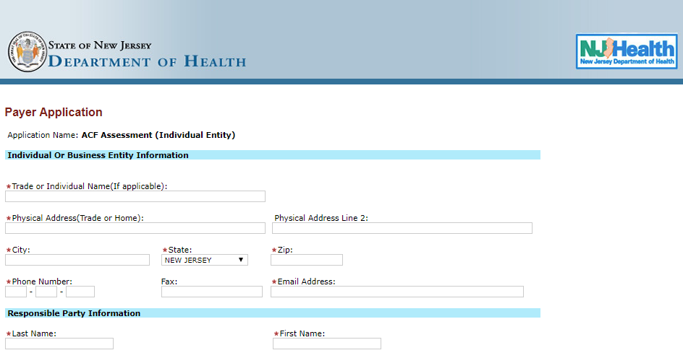
2
1
- Please check the Application Name. If, assessment payment or penalty payment. Also, if the payment type is individual or business based on your preference/selection.
- Please fill in the details as requested on the screen.
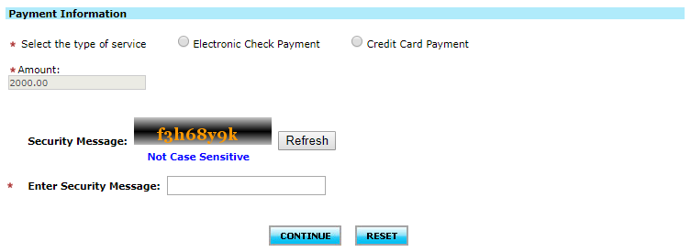
3
- Please enter the following details.
- Select the payment type. If, Electronic Check payment or Credit Card payment.
- Enter the amount you want to pay.
- Enter the security message/captcha. (It is not case sensitive)
- Click on “Continue” if you want to make the payment. In case you want to change/reset, please click on “Reset”.
If Electronic Check:
Once, you click “Continue”. You will see the details filled and the system asks you check.
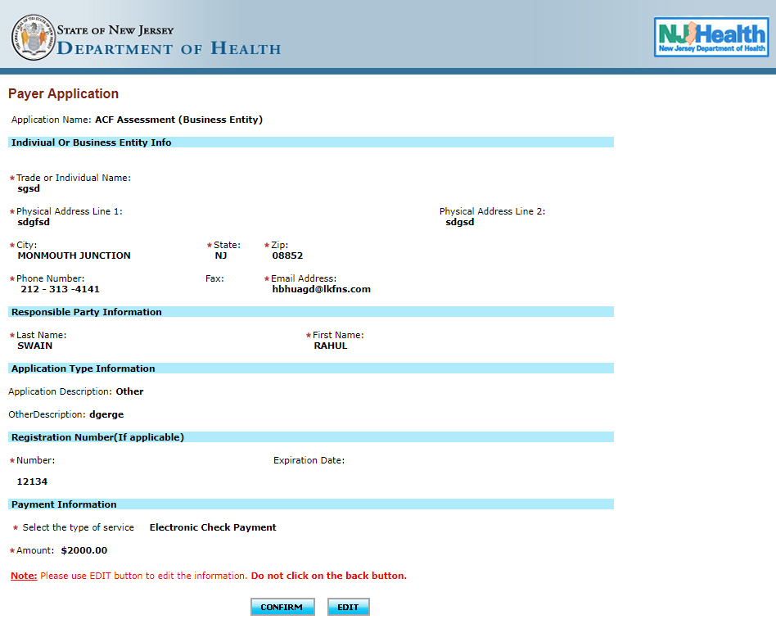
If everything looks good, please click on confirm. If not, please click on edit and you can make any changes that are required.

When clicked on continue, the system will redirect you the payment information page.
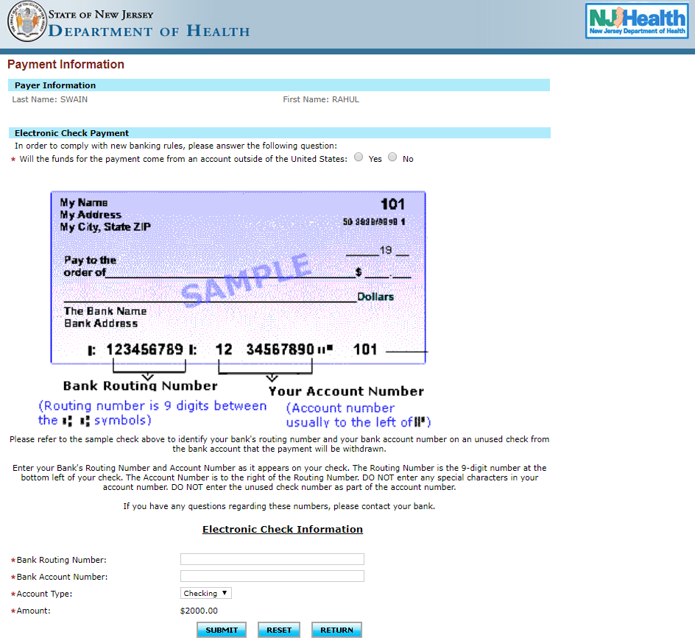
2
3
1
- Please, check in the displayed name is correct.
- Please, check mark the appropriate answer. (YES/NO)
- Please enter the bank details:
- Bank Routing #
- Bank Account #
- Account Type
NOTE: The amount is pre-populated whatever was included initially.
Please click on “Submit”, if you want to move forward and do the payment. In case you want to change/reset, please click on “Reset”. And in case you want to go back to the previous page, click om “Return”.

If Credit Card:
Once, you click “Continue”. You will see the details filled and the system asks you check.
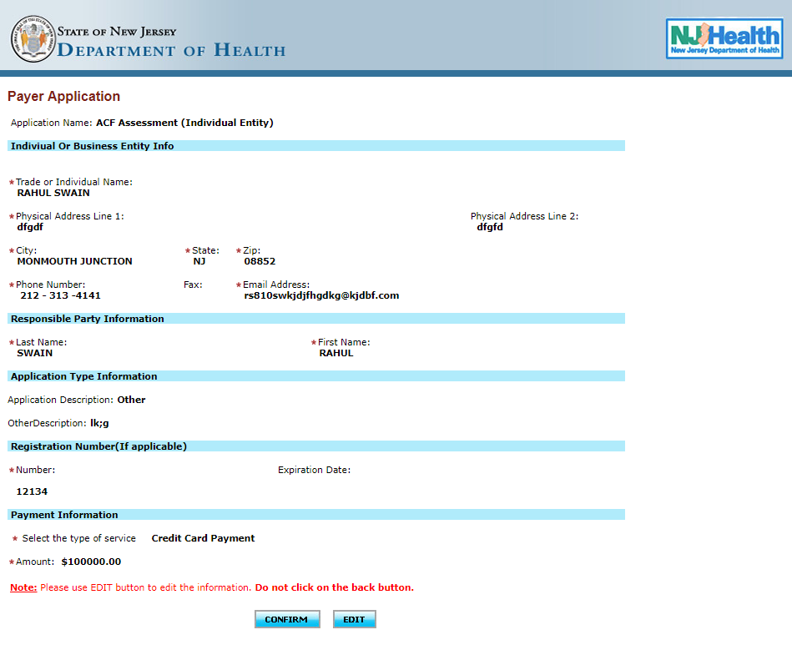
If everything looks good, please click on confirm. If not, please click on edit and you can make any changes that are required.

When clicked on continue, the system will redirect you the payment information page.
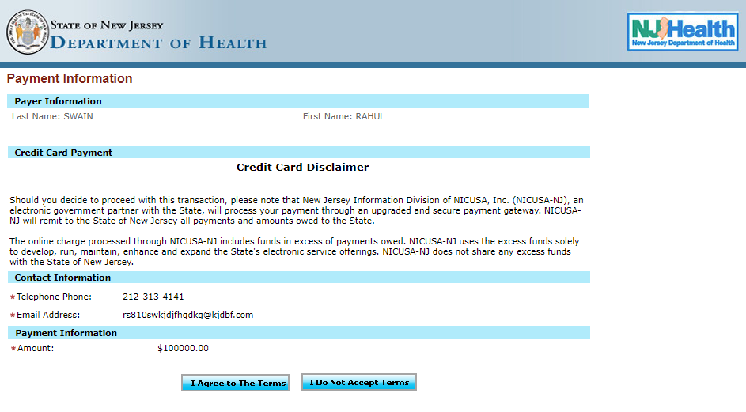
Please, verify the details on the screen. If everything looks okay, please click on “I Agree to The Terms”. If you are not sure, please click on “I Do Not Accept Terms.

